Using [zero-based numbering](https://en.wikipedia.org/wiki/Zero-based_numbering), the *n`*th Catalan number is given directly in terms of [binomial coefficients](https://en.wikipedia.org/wiki/Binomial_coefficient) by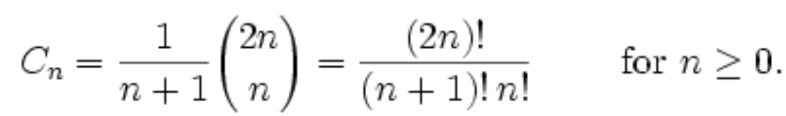

First few numbers are

[1](https://en.wikipedia.org/wiki/1_(number)), 1, [2](https://en.wikipedia.org/wiki/2_(number)), [5](https://en.wikipedia.org/wiki/5_(number)), [14](https://en.wikipedia.org/wiki/14_(number)), [42](https://en.wikipedia.org/wiki/42_(number)), [132](https://en.wikipedia.org/wiki/132_(number)), 429, 1430, 4862, 16796, 58786, 208012, 742900, 2674440, 9694845, 35357670, 129644790, 477638700, 1767263190, 6564120420, 24466267020, 91482563640, 343059613650, 1289904147324, 4861946401452

Properties:

* *Cn* is the number of [Dyck words](https://en.wikipedia.org/wiki/Dyck_word" \o "Dyck word)[[3]](https://en.wikipedia.org/wiki/Catalan_number#cite_note-3) of length 2*n*. A Dyck word is a [string](https://en.wikipedia.org/wiki/String_(computer_science)) consisting of *n* X's and *n* Y's such that no initial segment of the string has more Y's than X's. For example, the following are the Dyck words of length 6:

XXXYYY     XYXXYY     XYXYXY     XXYYXY     XXYXYY.

* Re-interpreting the symbol X as an open [parenthesis](https://en.wikipedia.org/wiki/Bracket#Parentheses) and Y as a close parenthesis, *Cn* counts the number of expressions containing *n* pairs of parentheses which are correctly matched:

((()))     ()(())     ()()()     (())()     (()())

* *Cn* is the number of different ways *n* + 1 factors can be completely [parenthesized](https://en.wikipedia.org/wiki/Bracket) (or the number of ways of [associating](https://en.wikipedia.org/wiki/Associativity) *n* applications of a [binary operator](https://en.wikipedia.org/wiki/Binary_operator)). For *n* = 3, for example, we have the following five different parenthesizations of four factors:

((ab)c)d     (a(bc))d     (ab)(cd)     a((bc)d)     a(b(cd))

* Successive applications of a binary operator can be represented in terms of a full [binary tree](https://en.wikipedia.org/wiki/Binary_tree). (A rooted binary tree is *full* if every vertex has either two children or no children.) It follows that *Cn* is the number of full binary [trees](https://en.wikipedia.org/wiki/Tree_(graph_theory)) with *n* + 1 leaves:

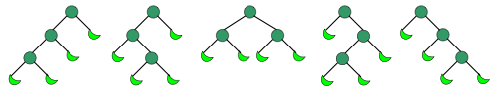

* *Cn* is the number of non-isomorphic ordered trees with *n* vertices. (An ordered tree is a rooted tree in which the children of each vertex are given a fixed left-to-right order.)[[4]](https://en.wikipedia.org/wiki/Catalan_number#cite_note-4)
* *Cn* is the number of monotonic [lattice paths](https://en.wikipedia.org/wiki/Lattice_path) along the edges of a grid with *n* × *n* square cells, which do not pass above the diagonal. A monotonic path is one which starts in the lower left corner, finishes in the upper right corner, and consists entirely of edges pointing rightwards or upwards. Counting such paths is equivalent to counting Dyck words: X stands for "move right" and Y stands for "move up".

The following diagrams show the case *n* = 4:

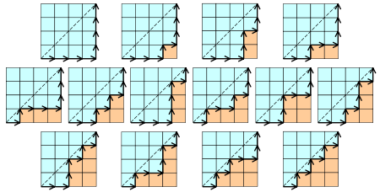

* *Cn* is the number of different ways a [convex polygon](https://en.wikipedia.org/wiki/Convex_polygon) with *n* + 2 sides can be cut into [triangles](https://en.wikipedia.org/wiki/Triangle) by connecting vertices with [straight lines](https://en.wikipedia.org/wiki/Straight_line)(a form of [Polygon triangulation](https://en.wikipedia.org/wiki/Polygon_triangulation)). The following hexagons illustrate the case *n* = 4:

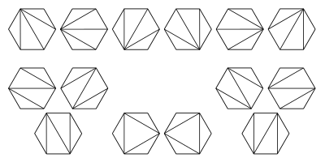

* *Cn* is the number of [stack](https://en.wikipedia.org/wiki/Stack_(data_structure))-sortable [permutations](https://en.wikipedia.org/wiki/Permutation) of {1, ..., *n*}. A permutation *w* is called [stack-sortable](https://en.wikipedia.org/wiki/Stack-sortable_permutation) if *S*(*w*) = (1, ..., *n*), where *S*(*w*) is defined recursively as follows: write *w* = *unv* where *n* is the largest element in *w* and *u* and *v* are shorter sequences, and set *S*(*w*) = *S*(*u*)*S*(*v*)*n*, with *S* being the identity for one-element sequences. These are the permutations that [avoid the pattern](https://en.wikipedia.org/wiki/Permutation_pattern) 231.
* *Cn* is the number of permutations of {1, ..., *n*} that avoid the pattern 123 (or any of the other patterns of length 3); that is, the number of permutations with no three-term increasing subsequence. For *n* = 3, these permutations are 132, 213, 231, 312 and 321. For *n* = 4, they are 1432, 2143, 2413, 2431, 3142, 3214, 3241, 3412, 3421, 4132, 4213, 4231, 4312 and 4321.
* *Cn* is the number of [noncrossing partitions](https://en.wikipedia.org/wiki/Noncrossing_partition" \o "Noncrossing partition) of the set {1, ..., *n*}. [*A fortiori*](https://en.wikipedia.org/wiki/A_fortiori_argument), *Cn* never exceeds the *n*th [Bell number](https://en.wikipedia.org/wiki/Bell_number). *Cn* is also the number of noncrossing partitions of the set {1, ..., 2*n*} in which every block is of size 2. The conjunction of these two facts may be used in a proof by [mathematical induction](https://en.wikipedia.org/wiki/Mathematical_induction) that all of the *free* [cumulants](https://en.wikipedia.org/wiki/Cumulant" \o "Cumulant) of degree more than 2 of the [Wigner semicircle law](https://en.wikipedia.org/wiki/Wigner_semicircle_law) are zero. This law is important in [free probability](https://en.wikipedia.org/wiki/Free_probability) theory and the theory of [random matrices](https://en.wikipedia.org/wiki/Random_matrices).
* *Cn* is the number of ways to tile a stairstep shape of height *n* with *n* rectangles. The following figure illustrates the case *n* = 4:

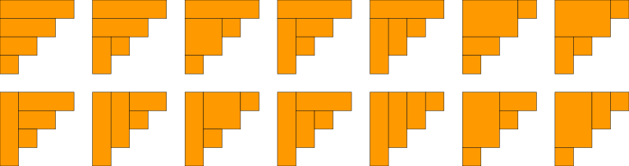

* *Cn* is the number of rooted [binary trees](https://en.wikipedia.org/wiki/Binary_tree) with *n* internal nodes (*n* + 1 [leaves](https://en.wikipedia.org/wiki/Tree_(graph_theory)#Definitions) or external nodes). Illustrated in following Figure are the trees corresponding to *n* = 0,1,2 and 3. There are 1, 1, 2, and 5 respectively. Here, we consider as binary trees those in which each node has zero or two children, and the internal nodes are those that have children.

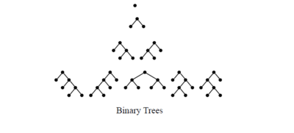

* *Cn* is the number of ways to form a “mountain ranges” with n upstrokes and n down-strokes that all stay above the original line.The mountain range interpretation is that the mountains will never go below the horizon.

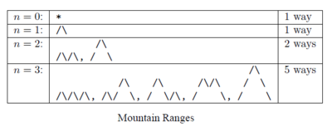

* *Cn* is the number of [standard Young tableaux](https://en.wikipedia.org/wiki/Young_tableau#Tableaux) whose diagram is a 2-by-*n* rectangle. In other words, it is the number of ways the numbers 1, 2, ..., 2*n* can be arranged in a 2-by-*n* rectangle so that each row and each column is increasing. As such, the formula can be derived as a special case of the [hook-length formula](https://en.wikipedia.org/wiki/Young_tableau#Dimension_of_a_representation).
* *Cn* is the number of ways that the vertices of a convex 2*n*-gon can be paired so that the line segments joining paired vertices do not intersect. This is precisely the condition that guarantees that the paired edges can be identified (sewn together) to form a closed surface of genus zero (a topological 2-sphere).
* *Cn* is the number of [semiorders](https://en.wikipedia.org/wiki/Semiorder" \o "Semiorder) on *n* unlabeled items.
* In chemical engineering *Cn* is the number of possible separation sequences which can separate a mixture of *n* components.[[7]](https://en.wikipedia.org/wiki/Catalan_number#cite_note-7)